Nice chill maps for the Mediterranean region

**Authors (Erica, Hajar, Theresa, Eduardo, Eike, Partners?)**

Department of Horticultural Sciences, Institute of Crop Science and Resource Conservation (INRES), University of Bonn, 53121 Bonn, Germany

*Corresponding author:

**Abstract**

**Keywords:**

# Introduction

# Materials and methods

## Weather data collection

We identified 5,000 weather stations near the Mediterranean Sea available from the Global Summary Of the Day database (GSOD). We filtered this list of weather stations to retain those starting the records before 1974 and ending the recording after 2020. A second criteria for excluding weather stations from the analysis was the latitude. We excluded from the analysis the weather stations located above 48 °N and below 25 °N. These filtering procedures resulted in 792 weather stations for which we downloaded temperature records from the GSOD database. After downloading, we retained the weather stations showing at least 90% of data complete for minimum and maximum temperatures. This process resulted in 374 weather stations having a mean data completeness of 97% for minimum and maximum records (430 and 427 missing days out of 17,167 intended records, respectively). Due lack of weather stations in some areas of northern Africa, we also included 13 weather stations from Libya and Egypt showing between 70% and 87% of data complete for minimum and maximum records (see supplementary materials Table S1 for additional information from all 387 weather stations).

## Gap filling procedure

We filled the gaps in the primary weather stations following the procedures described in similar previous studies (CITATIONS) with some modifications. In brief, we used data from auxiliary weather stations to fill the gaps in our main weather stations after correction for a bias estimate. These auxiliary sources of data were 712 weather stations (from the same database) showing at least 20% of data complete for minimum and maximum temperatures between 1975 and 2020. We compared the records in the primary weather stations to each of the 712 auxiliary sources of data for all days showing records in both data frames. For minimum and maximum records, we computed the mean difference and standard deviation of the difference relative to the primary weather stations. We excluded auxiliary weather stations showing a mean difference greater than 3 °C for both metrics to retain only representative sources of data. After sorting the list of auxiliary weather stations according to mean difference, we filled the gaps in the primary data frame with data from the auxiliary weather station after subtracting the mean differences. This process was implemented for each primary station using one auxiliary station at a time until no alternative sources of data were available.

Since the procedure described above was insufficient to fill all gaps in the primary weather stations, we implemented a second approach to fill the remaining gaps using data from the Prediction Of Worldwide Energy Resources (POWER) project led by NASA. We first downloaded daily extreme records from the NASA POWER database for the 387 weather stations. This database contains historic grided data between 1981 and 2020. We then filled the remaining gaps in the primary data set with data downloaded from the NASA POWER database after applying the respective bias correction. In this version of the patching procedure, we computed the bias correction as the mean difference between databases for the same location (i.e. mean difference for minimum and maximum records between GSOD and NASA POWER). Since we were using data from the same exact locations but from different sources, we did not set a bias threshold to exclude weather stations in this stage of the gap filling procedure. Our two gap filling approaches resulted in 24 weather stations showing about 100 missing days. After removing these stations, we obtained 363 sources of extreme records showing a maximum of 25 and 45 missing days for minimum and maximum records, respectively. We filled these remaining gaps through linear interpolation (CITATION) as reported in previous studies (CITATIONS).

## Temperature generation for assessing historic and future scenarios

We evaluated historic scenarios by computing winter chill accumulation in each year of the gap-free data set. Additionally, we analyzed winter chill accumulation based on historic simulated scenarios (CITATIONS) to enhance the ability of the analysis to identify reliable medium- and long-term trends from records. To this end, we generated 10 historic scenarios representing the conditions of the years 1975 to 2019 (each five years). For each of these scenarios, we computed monthly mean for minimum and maximum records based on a running mean function spanning 15 years of records. We then introduced these scenarios into a weather generator (CITATION) to produce 101 years of synthetic data representing the likely conditions of each particular year. This allowed us analyzing the historic chilling conditions of the Mediterranean based on a distribution of 100 probable chill values for each simulated scenario.

For future conditions, we used a similar approach as the method described above with a slight modification. In this case, we used monthly mean temperature extremes obtained from the ClimateWizard data base (maintained by the International Center for Tropical Agriculture – CIAT) as input for the weather generator. ClimateWizard contains future temperature estimations generated by 15 General Circulation Models (GCMs, supplementary materials Table S2) for two Representative Concentration Pathway scenarios (RCPs) and various time horizons. In this study, we assessed chill conditions under the scenarios RCP4.5 and RCP8.5 by the period 2035 – 2065 (represented by the year 2050) and 2070 – 2100 (represented by the year 2085). Since the ClimateWizard database had no future projections for some weather stations located specially in small islands of the Mediterranean Sea, we removed 6 weather stations at this stage of the analysis.

## Computation of chilling metrics

We computed winter chill accumulation in terms of Chill Portions (CP) according to the Dynamic model (CITATIONS). Compared to other alternatives, the Dynamic model has emerged from model comparison studies as the most adequate model for chill estimation in mild winter climates (CITATIONS). Since the Dynamic model requires hourly temperatures as input, we derived hourly records from daily extremes based on an idealized daily temperature curve (CITATIONS). This curve depends on the latitude of a place and uses a sine function for daytime warming and a logarithmic decay function for nighttime cooling (CITATIONS). We defined the winter season for chill accumulation between November 1 and March 1 for all scenarios and years.

Chill was computed for the 357 weather stations for i) all years in record (observed chill), ii) all synthetic years for each past scenario (historic simulated chill), and iii) all synthetic years for each combination of GCM, RCP, and time horizon. To summarize the results and provide farmers with a risk-related estimate, we used the concept of Safe Winter Chill (SWC, CITATION). SWC is calculated as the 10th quantile of the chill distribution and represents the chill that is likely to be exceeded in 90% of years. This metric therefore helps farmers identify scenarios under which the cultivation of temperate fruit species may no longer be viable. We computed SWC for the whole observed period (across 46 years), each historic simulated scenario (across 100 winter seasons each), and each combination of GCM, RCP, and time horizon (across 100 winter seasons each). We reduced the number of scenarios generated by the climate models by producing an “optimistic”, an “intermediate”, and a “pessimistic” climate model selection. These climate model classes where defined as the 15th, 50th, and 85th quantile of the SWC distribution, respectively across 15 climate models.

## Spatial interpolation of Safe Winter Chill

We implemented the methods developed by CITATION and CITATION to interpolate SWC in the Mediterranean area. In a preliminary stage, we used latitude and longitude as predictors of SWC to develop a chill surface covering the area of interest. We corrected this preliminary interpolation using two co-variables with a known spatial distribution such as monthly minimum and maximum temperatures in January. To this end, we downloaded historical grided data for the period 1970 – 2000 for the two co-variables with a resolution of 30 seconds (~1 km2) from the WorldClim database (CITATION). In addition to the WorldClim data, we computed the values for these co-variables (monthly minimum and maximum temperatures in January) using the records from the weather stations and implemented an ordinary kriging based on longitude and latitude. To retain weather stations showing comparable values between databases for the two co-variables, we removed from the analysis the weather stations for which the difference between WorldClim and on-site data was greater than 2 °C. This process resulted in 346 weather stations used for the spatial interpolation of SWC. We then created a 3D correction model using data recorded on-site from the weather stations. This 3D correction model considered the monthly minimum and maximum temperature of January (x and y axis, respectively) and the SWC (contour surface) for a given combination of the two co-variables (CITATION). We introduced the data for monthly minimum and maximum temperature from both databases (WorldClim and on-site records) to the correction model and obtained a surface of SWC estimation. By subtracting the surface generated with the on-site data to the one generated with the WorldClim data, we obtained a SWC correction map that was later added to the preliminary SWC interpolation using longitude and latitude. This allowed us generating a SWC map for the Mediterranean region based on the coordinates as well as two correction co-variables. We implemented this interpolation procedure for the historic observed, all historic simulated, and all future scenarios.

## Cross-validating the spatial interpolation

We implemented a cross-validation procedure to assess the performance of the spatial interpolation method. In general, this procedure aimed to compare the estimation of SWC in a location using all 346 weather stations versus the estimation for the same place using a sample of stations to implement the interpolation. We first split the main data frame of weather stations into 8 sub data frames to be used as part of the evaluation and training procedure at different times. For instance, one of the 8 data sets is once part of the evaluation process whereas the remaining 7 times is merged into a big training data frame (generating the SWC estimates). We implemented this procedure until all sub data sets were part of the evaluation process. We later obtained the residuals for the weather stations by subtracting the value obtained with the validation procedure to the original SWC value estimated using all weather stations. Since the interpolation method used a different 3D correction model for each scenario evaluated, we implemented the cross-validation procedure for all scenarios described in section “2.4. Computation of chilling metrics.” Additionally, we used a cross-validation procedure using five repetitions to reduce the possible bias while splitting the main data frame. We summarized the results by computing the median and standard deviation for the residual across scenarios and repetitions.

## Collecting chilling experiences from Mediterranean fruit production areas

To position our results in a real case context, we collected expert knowledge from farm advisors and researchers working with temperate fruit trees in the Mediterranean region. We gathered inputs from experts working in Tunisia, Morocco, and south- and northeastern Spain. The main topics we aimed to cover with this analysis were the current situation regarding chill accumulation in the main growing areas, challenges and concerns of farmers regarding future scenarios, noticeable changes in the array of species and/or cultivars grown in the region, and noticeable modifications in the production cycle of temperate fruits. Rather than implementing a structured method for collecting information, we aimed to generate a more narrative perspective of the situation in the Mediterranean region. We finally used these inputs to discuss the main results of our study.

## Data processing tools, figure generation, and reproducibility

All data processing, analyses, and figure preparation were implemented in the R programming environment (CITATION). For agroclimatic analyses such as weather data collection and chill computation we used the chillR package (CITATION). For generation of synthetic temperatures we used the RMAWGEN package (CITATION) through functions in the chillR package. For figure preparation we used the tmap package (CITATION). All scripts, analyses and figures generated in this study are available at a public GitHub repository (https://github.com/EduardoFernandezC/chill_mediterranean).

# Results

## Historic observed chill accumulation in the Mediterranean

Overall, historic observed levels of SWC in the Mediterranean region ranged between 30 CP and 100 CP (Fig. 1). The lower bound of this range was observed in small areas of northern Africa such as northeast and central Tunisia, western Morocco, and northern Libya. However, SWC levels of about 60 CP were also observed in some areas of these countries. The areas with the greatest observed chill were inland regions of Spain, northern Italy, and most of France. In these countries, SWC reached a median of about 90 CP between 1975 and 2020. Many countries of east Europe showed SWC values between 40 CP and 60 CP.

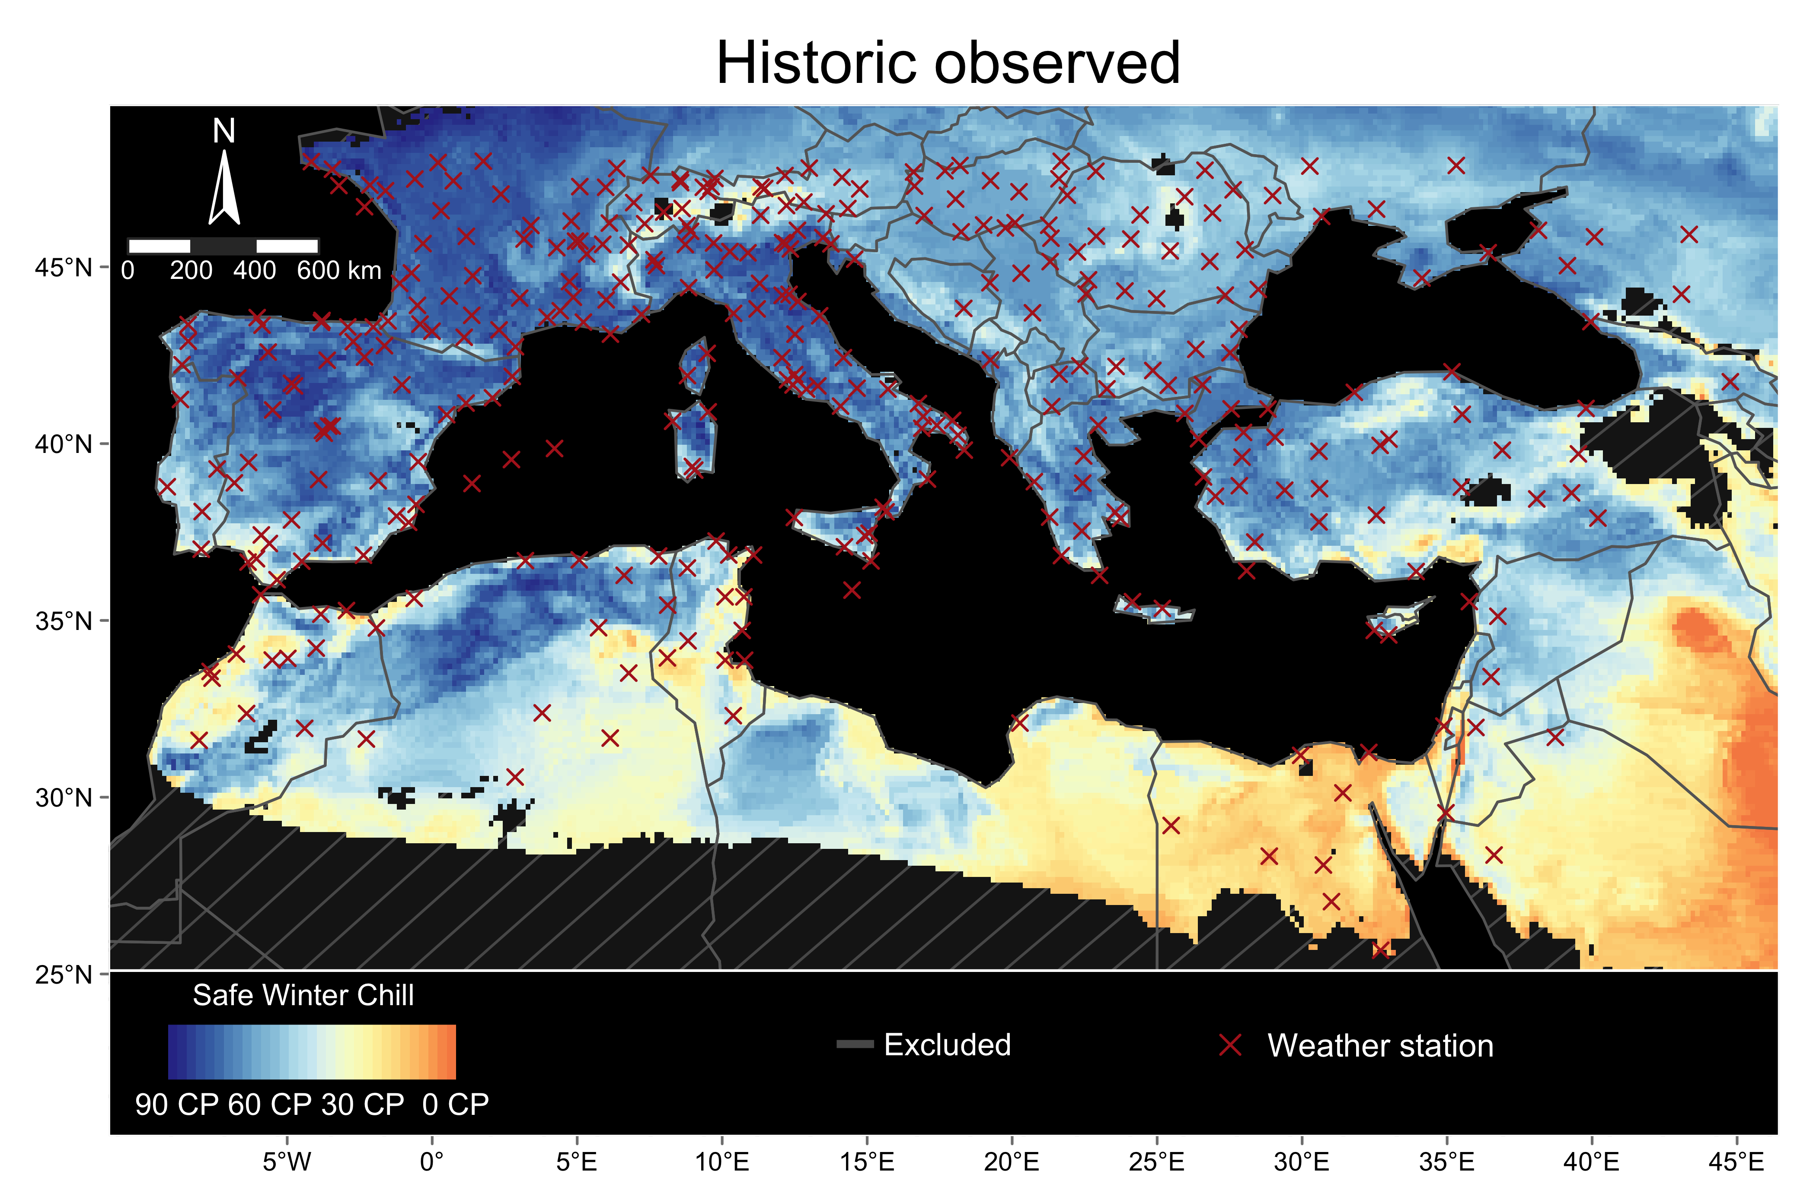

Figure 1. Safe Winter Chill (SWC) in the Mediterranean region for a historic scenario. The color legend shows the median of observed SWC between 1975 and 2020 computed in Chill Portions (CP) according to the Dynamic model. The grey hatched areas in the map represent regions excluded from the 3D correction model. The red crosses show the location of the weather stations used in this analysis

## Absolute chill levels and change based on historic simulated scenarios

We observed similar results when comparing the median SWC for historic observed and historic simulated scenarios (Fig. 1 and upper panel in Fig. 2). When analyzing SWC changes between 1975 and 2019 (based on historic simulated scenarios), we observed that many countries from the Mediterranean region have experienced considerable SWC losses (bottom panel in Fig. 2). Inland areas of Spain, Portugal, Greece, and Turkey showed a reduction of about 20 CP. Similar values were observed in western Tunisia, southern France, and most areas of Italy. Smaller SWC reductions by about 10 CP were observed in northern France, southern Spain, and some regions of northern Africa. Conversely, major chill increases in SWC were observed between 1975 and 2019 in southern Germany, Austria, Ukraine, among others.

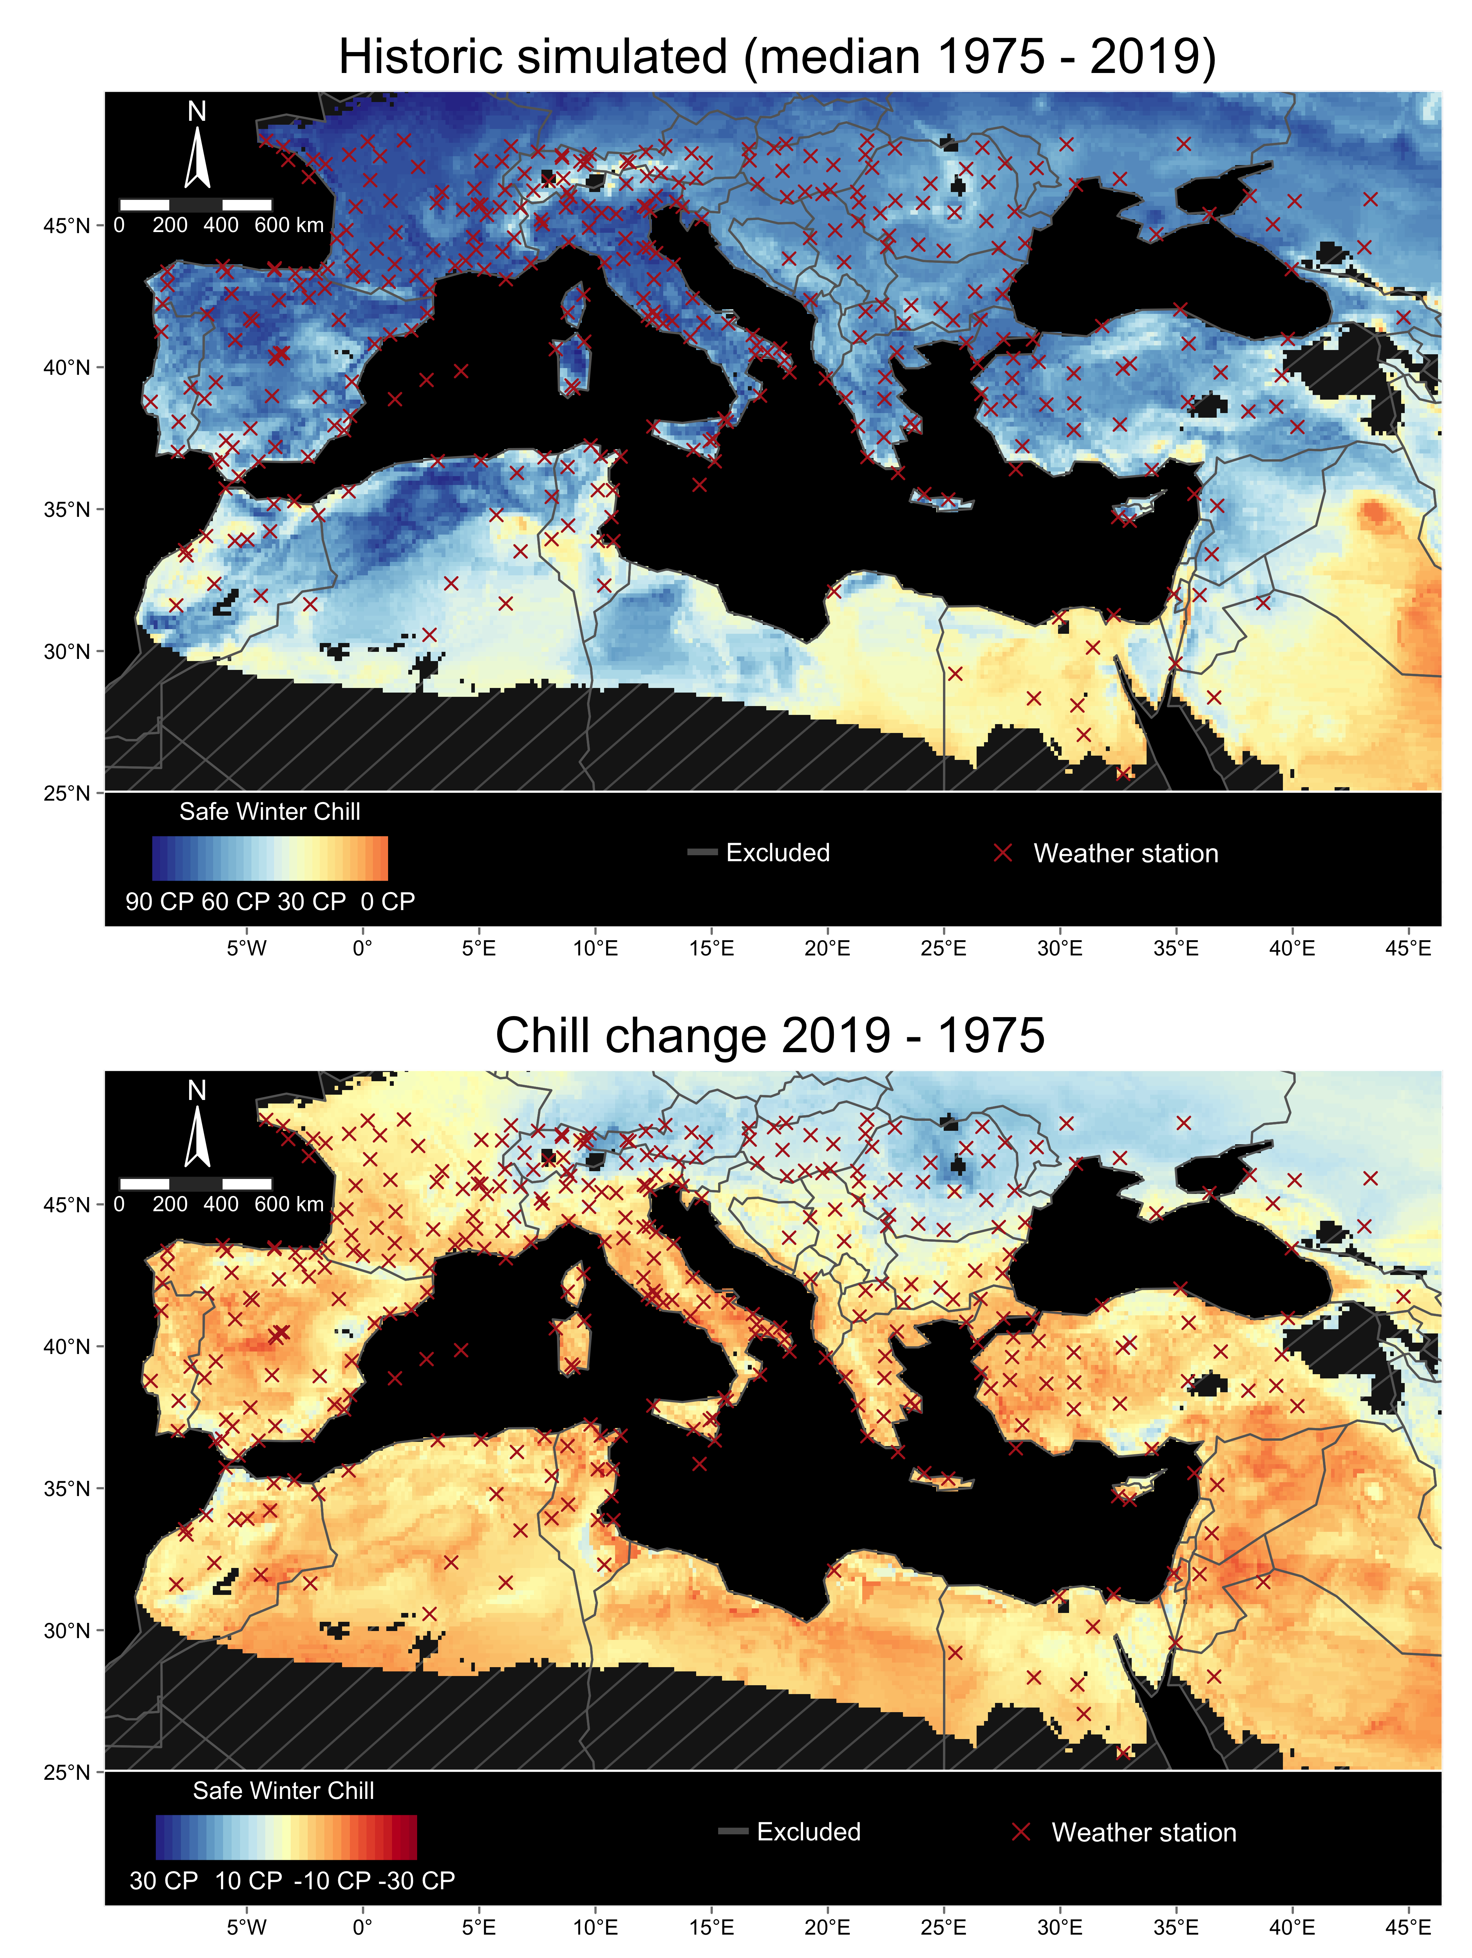

Figure 2. Safe Winter Chill estimation for the Mediterranean region based on historic simulated scenarios. In the upper panel, we show the median SWC (in Chill Portions) computed across 10 historic simulated scenarios between 1975 and 2019. In the bottom panel, we show the difference in SWC between the historic simulated scenarios 2019 and 1975. In both panels, the grey hatched areas represent regions excluded from the 3D correction model. The red crosses represent the location of the weather stations used in the analysis

## Chill changes in the Mediterranean under future scenarios

Future SWC levels in the Mediterranean mainly depend on the global warming scenario and time horizon evaluated. Under the RCP4.5 by 2050, chill is likely to decline by about 20 CP in many areas of northern Africa such as the coastal regions of Morocco, Argelia, and Tunisia (Fig. 3). Similar results were projected for the southern cost of Spain and Italy. In continental areas of southern Europe, the likely decline may range between 5 CP and 10 CP (Fig. 3). Minor increases in SWC were projected in high-elevation regions of southern France, northern Italy, and Ukraine.

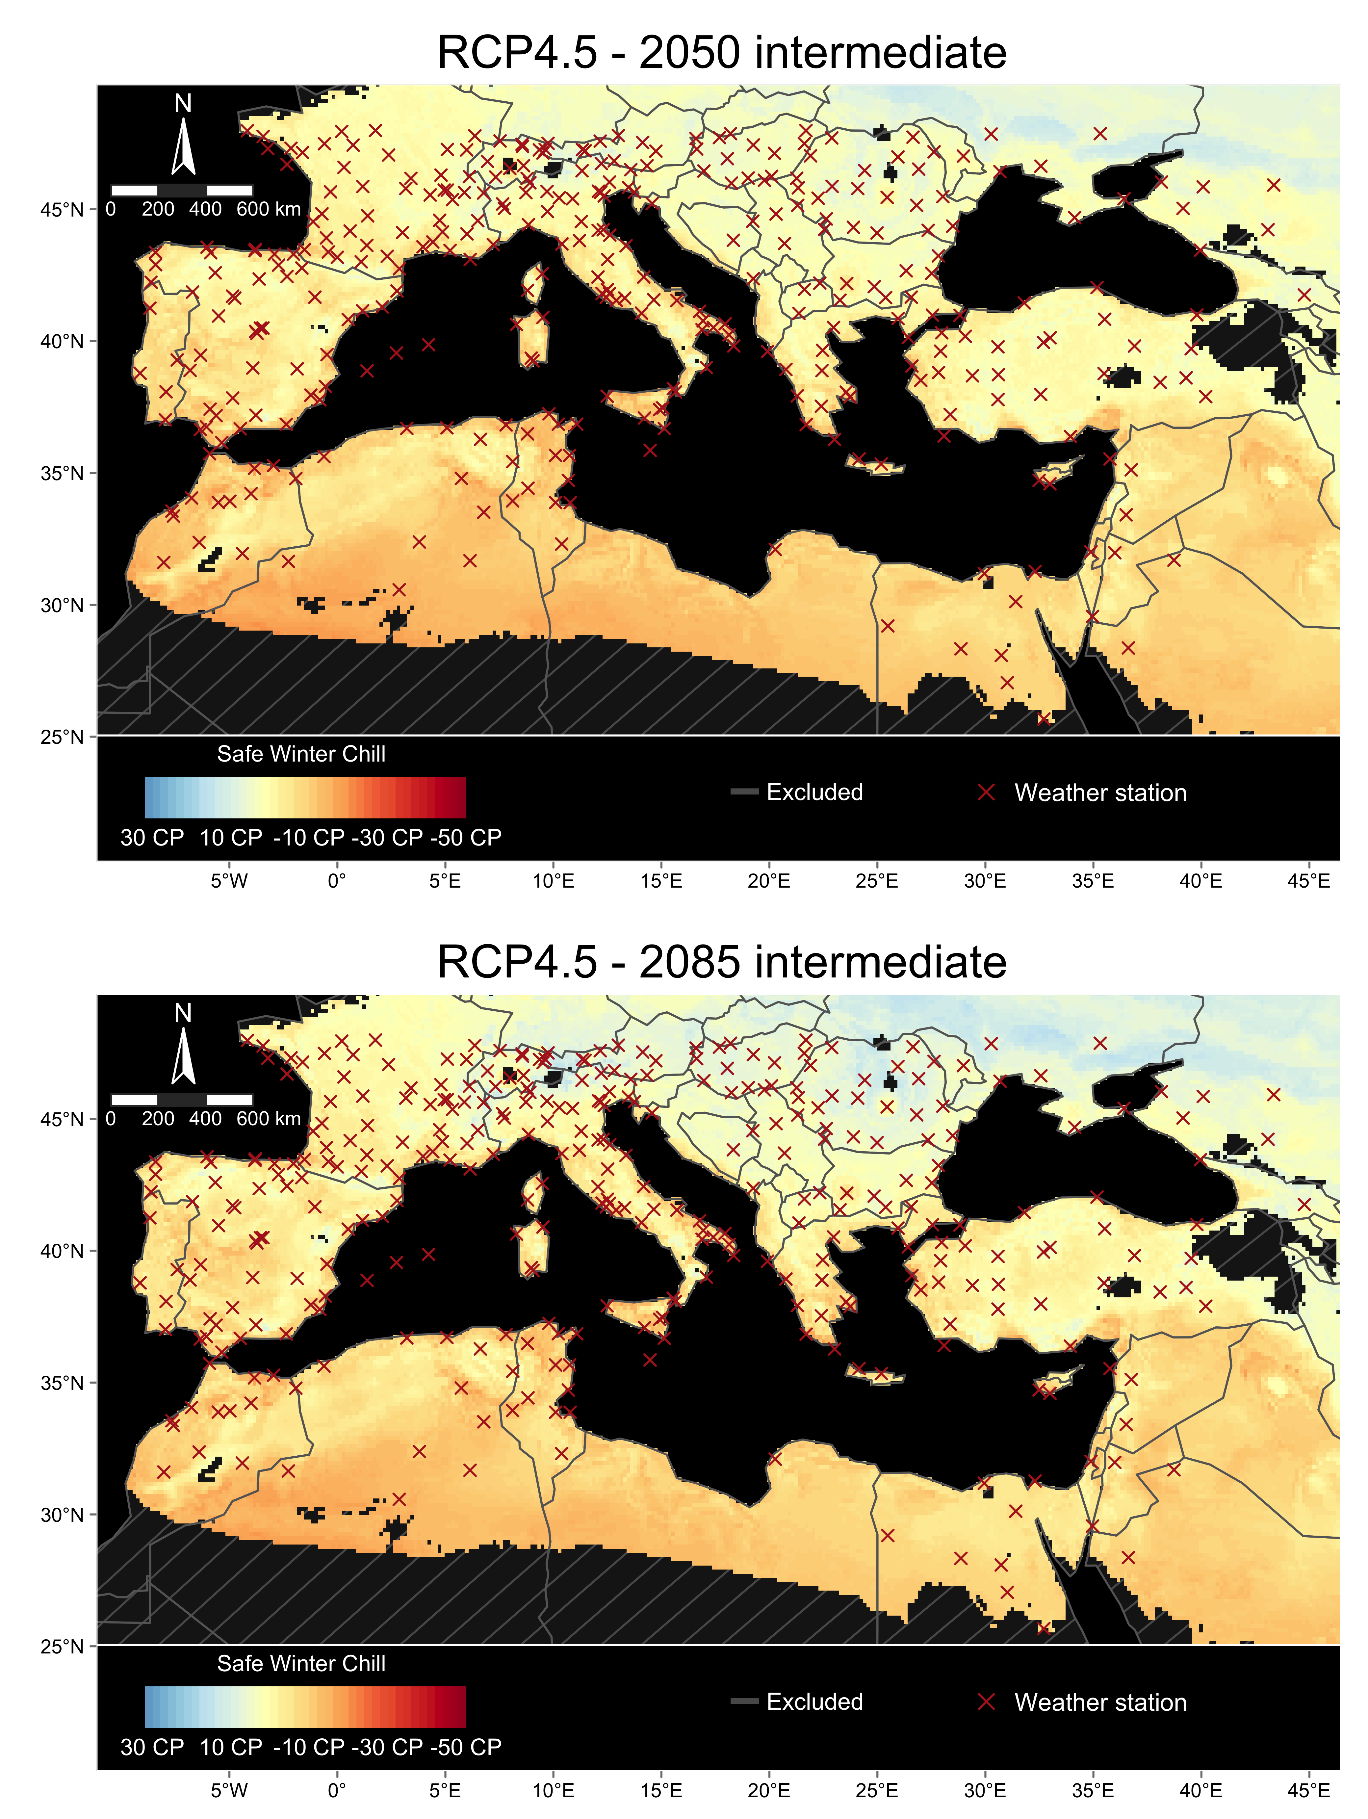

Figure 3. Estimation of Safe Winter Chill change for the Mediterranean region under the RCP4.5 scenario by two time horizons relative to historic simulated scenarios. In both panels, we show the difference in SWC between the respective combination of future scenario and year and the median across historic simulated scenarios between 1975 and 2019. For future scenarios, we used the results of the “intermediate” climate model distribution (median SWC value among 15 General Circulation Models). The grey hatched areas in the maps represent regions excluded from the 3D correction model. The red crosses represent the location of the weather stations used in the analysis

Under the RCP8.5 changes in SWC across the Mediterranean region are more dramatic (Fig. 4). By 2050, chill levels in most areas of northern Africa are likely to decline by about 30 CP compared to the historic median between 1975 and 2019. Some regions of western Tunisia, north Argelia, and central Morocco might experience a decline between 15 and 20 CP by the same year. Similar results were projected for most regions of Portugal, and southwestern and southern Spain. Minor chill increases by about 10 CP were projected for some small areas of northern and eastern Spain.

By 2085, chill decline may range between 20 and 40 CP in Morocco, Argelia, Tunisia, and the Mediterranean coastal areas of Spain, Italy, Greece, and France. Smaller declines by about 10 CP are projected for inland areas of Spain, France, Italy, and Turkey. Our results highlight important chill increases in many countries of eastern Europe.

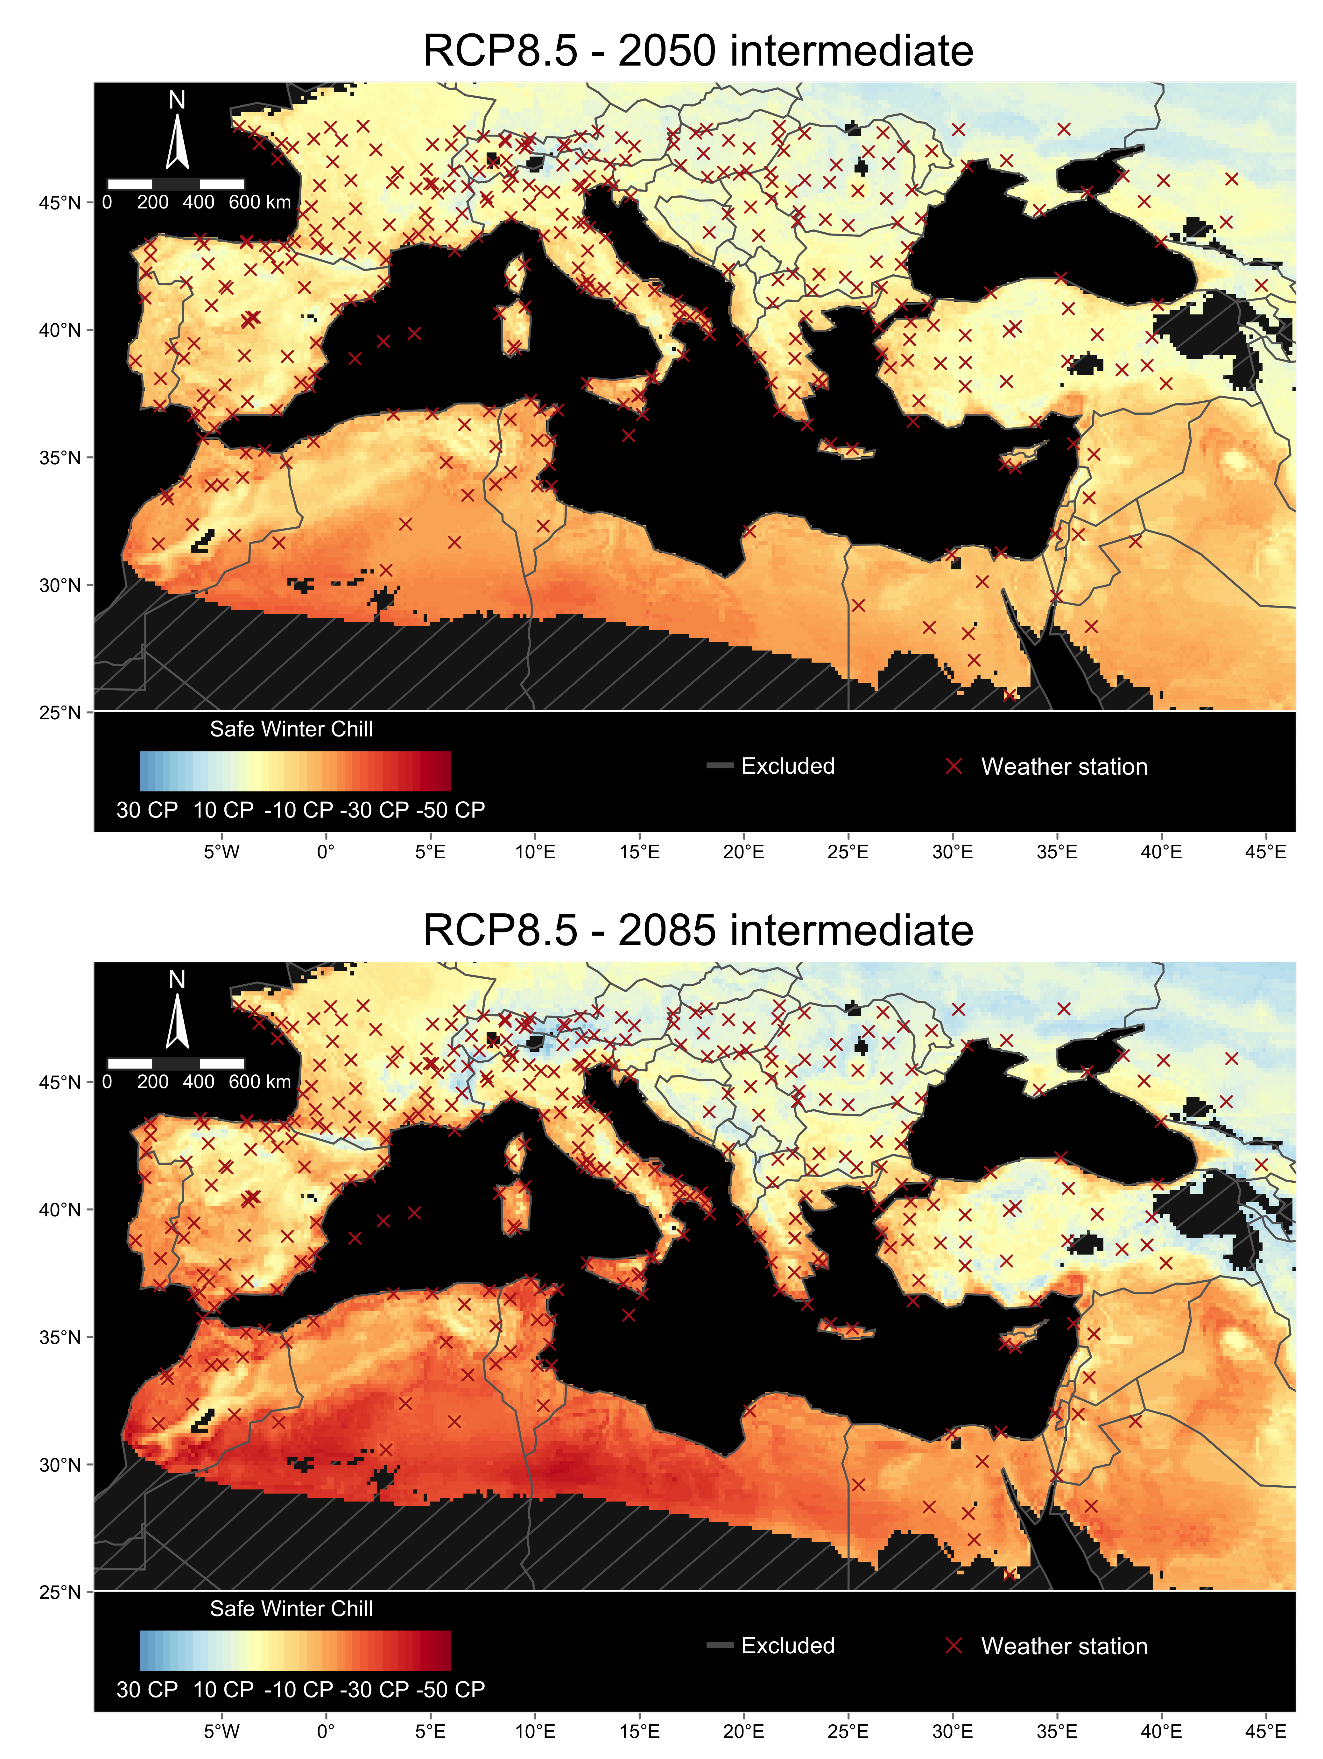

Figure 4. Estimation of Safe Winter Chill change for the Mediterranean region under the RCP8.5 scenario by two time horizons relative to historic simulated scenarios. In both panels, we show the difference in SWC between the respective combination of future scenario and year and the median across historic simulated scenarios between 1975 and 2019. For future scenarios, we used the results of the “intermediate” climate model distribution (median SWC value among 15 General Circulation Models). The grey hatched areas in the maps represent regions excluded from the 3D correction model. The red crosses represent the location of the weather stations used in the analysis

## Assessing the performance of the interpolation method

In general, the interpolation method showed a good performance (Fig. 5). The median residuals, computed for each weather station across scenarios and replications, ranged from -3.30 CP (Q25%) to 4.49 CP (Q75%) and showed a central value of 0.56 CP. Likewise, the standard deviation of residuals ranged between 2.18 CP (Q25%) and 4.32 CP (Q75%), and showed a median of 3.09 CP.

Despite the overall good performance of the method, we identified a few weather stations showing extremely different values for the median residuals than most locations. In this regard, we highlight the weather stations at Jungfraujhoch (46.6 °N and 7.9 °E, 1,571 meters above sea level), Mussala (Top-Sommet, 42.2 °N and 23.6 °E, 2,575 meters above sea level), and Varfu Omu (45.4 °N and 25.4 °E, 1,631 meters above sea level). For these stations, we computed median residuals by -66.6 CP, -43.8 CP, and -39.7 CP, respectively. Similarly, we identified 22 weather stations for which the cross-validation procedure did not provide a value for estimating the median residual. This resulted from these weather stations showing a combination of minimum and maximum temperature falling outside the 3D correction model generated with the respective sub data sets used for cross-validation.

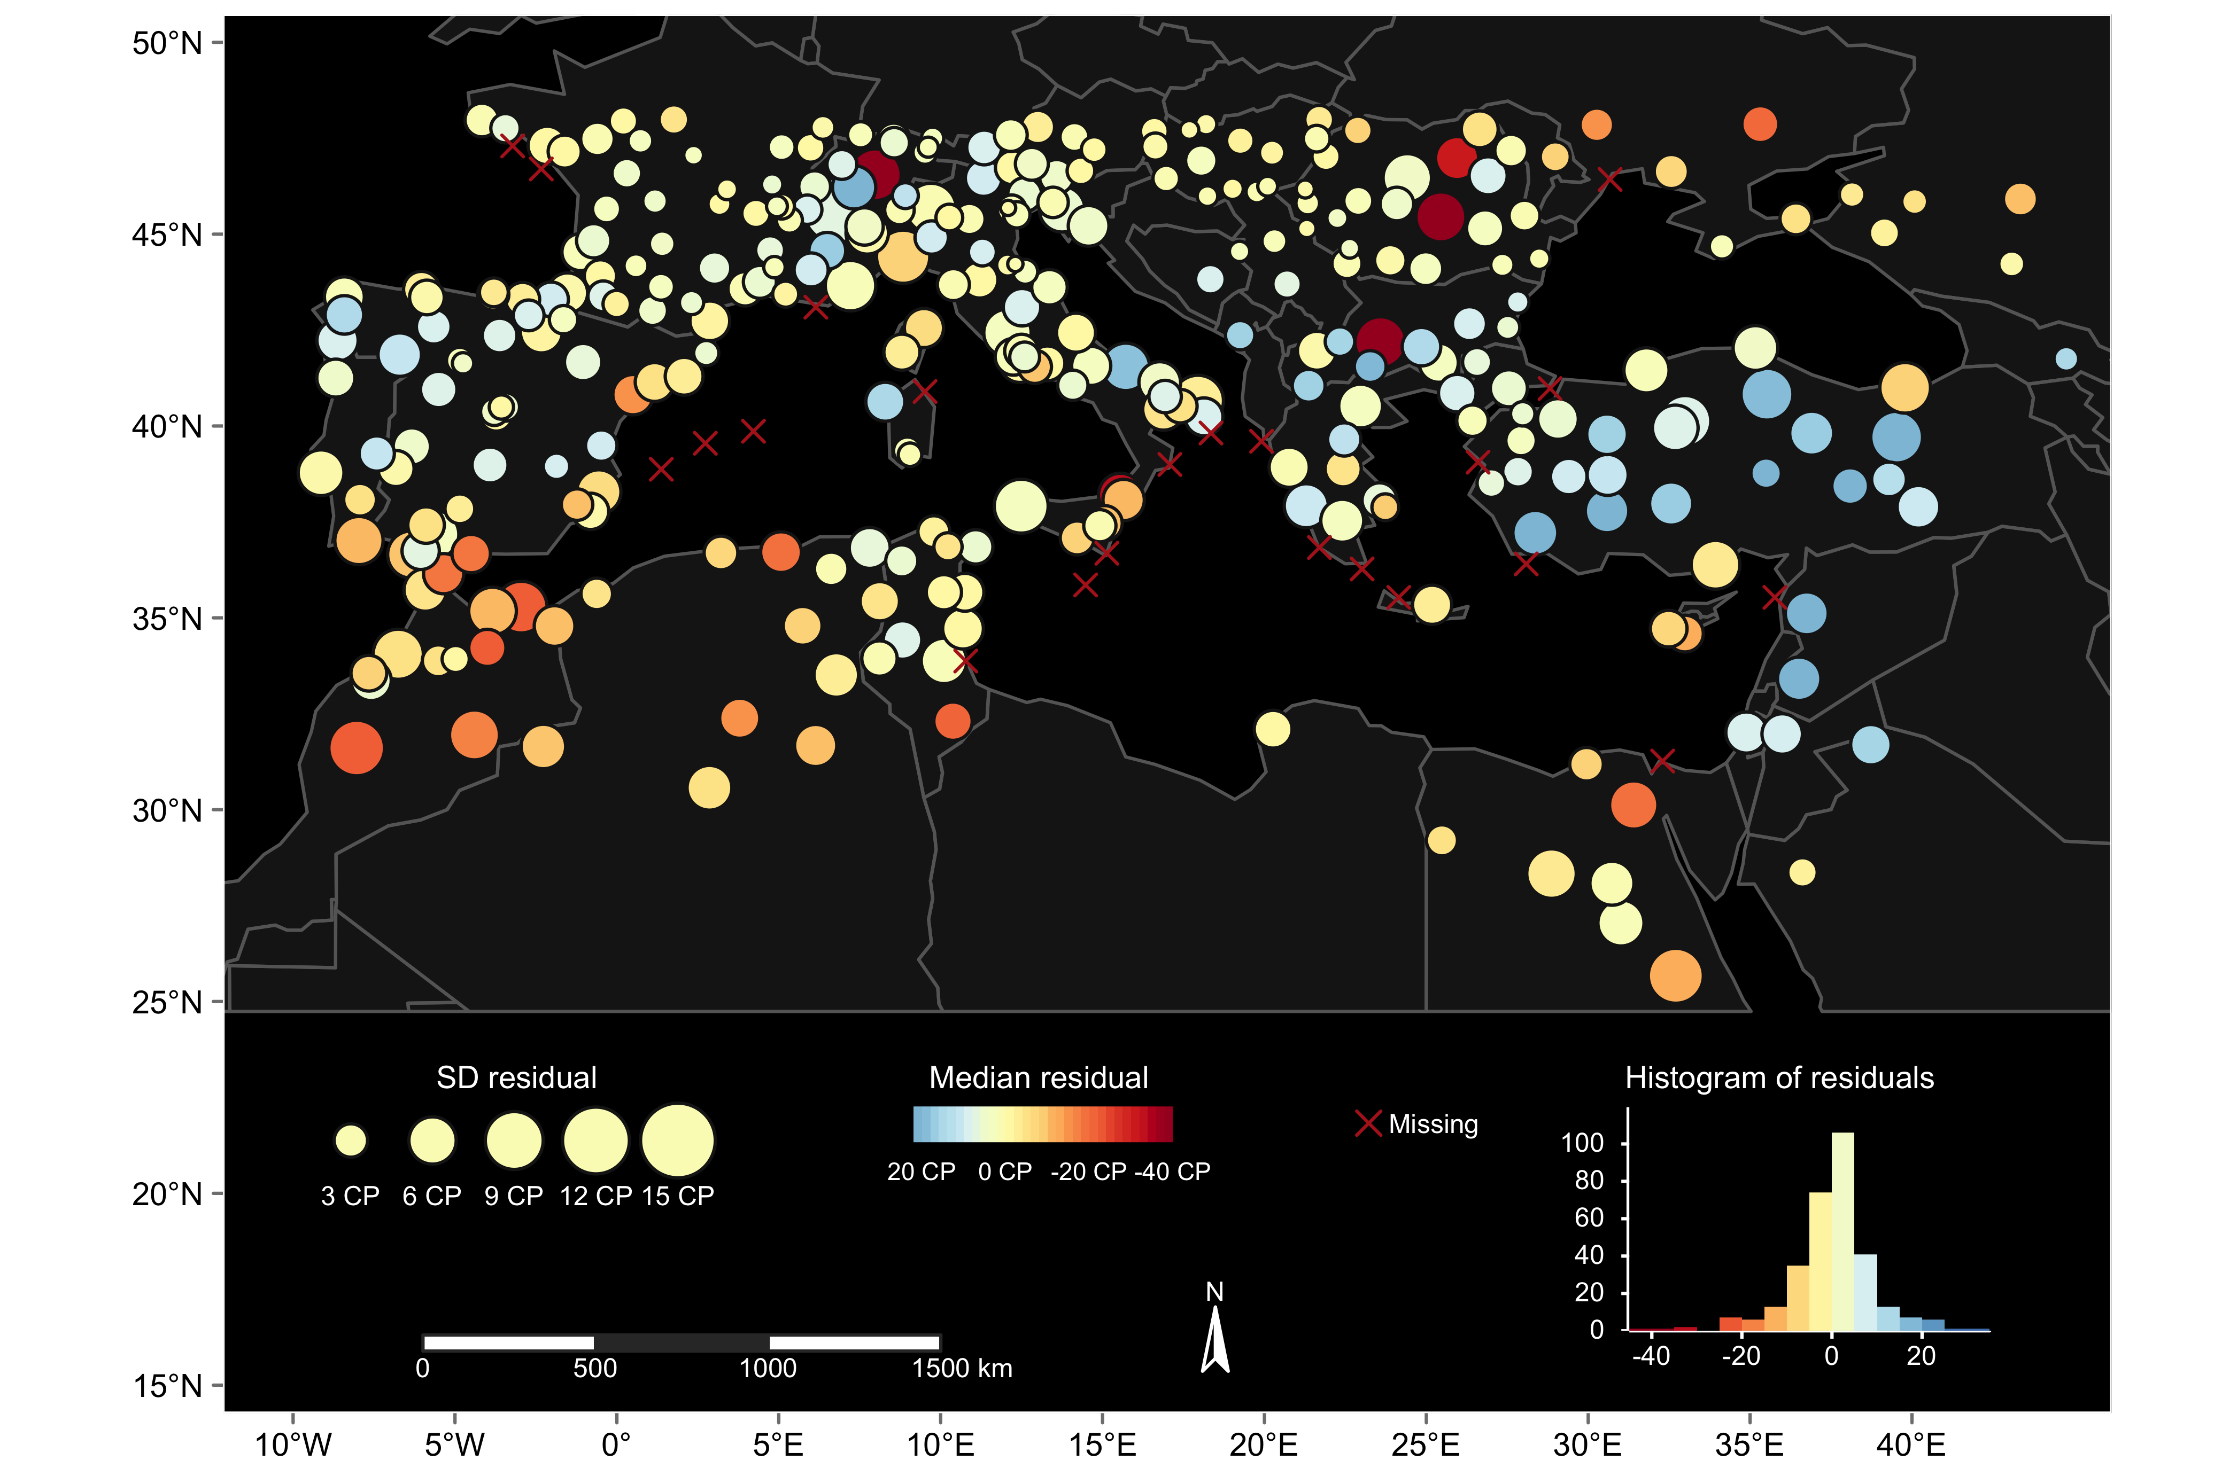

Figure 5. Results of the cross-validation procedure implemented to assess the performance of the interpolation method. In each location, the size of the bubble represents the standard deviation of the residuals (among scenarios and replications) whereas the color represents the median residual (in Chill Portions). The red crosses represent weather stations for which the cross-validation procedure assigned missing values due exclusion of these stations from the 3D correction model. The histogram in the bottom left corner shows the distribution of the residuals

## Experiences from Mediterranean regions

# Discussion

# Conclusions

# Conflict of interest

# Author contributions

# Funding

# Acknowledgement

# References